Customer Needs and Requirements

1. **Introduction**

The idea of the project is to create a bridge shaker that, when placed on a bridge, will excite multiple frequencies and modes within that bridge. Dr. Austin Downey has tasked us with testing the bridges' natural daily frequencies and then creating a machine that will replicate these frequencies. Dr. Austin Downey wants this device to be able to test a wide variety of bridges and to gather information on the structural integrity and health of the bridge.

1. **Methodology**  
   Through speaking with the project sponsor and supporting teammates, we were able to identify certain criteria they wanted met. Certain aspects about size and procedures were discussed on how to set the parameters for our shaker design as well as the functionality of the shaker for further use outside of this project.
2. **Interpretation of Needs** 
   1. Needs to be used to test vibration data – the bridge shaker must be able to shake the bridge being tested at a high enough frequency to match our control data.
   2. Needs to ideally excite the fourth or fifth mode – the shaker needs to be able to shake the bridge well enough that the fourth and fifth mode can be seen on an FFT diagram.
   3. Needs to have a max range based on experimental data gathered by accelerometers – testing data from normal bridge activity must be recorded to create a baseline for the shaker to operate at.
   4. Needs to be robust – the design of the shaker needs to be simple and easy to put together, must not be too complex.
   5. Needs to be usable after we leave – the shaker needs to remain a useful tool for future experiments even after this one is over.
   6. Needs to be site flexible – it must be applicable to a multitude of different bridge sizes and dimensions; needs to be simple enough for a wide range of applications
   7. Needs to be portable – by making the shaker light and easy to carry, the shaker will be able to be used in a variety of different locations.
   8. Needs to be user friendly – the controls and functionality of the shaker need to be simple enough so that someone with a little experience can operate the machine.
   9. Needs to run off a portable power supply – some bridges may not have an outlet nearby for us to supply power to the shaker, therefore it will need some sort of internal power system.
   10. Needs to tell the frequency it is operating at – a display for the current frequency the shaker is operating at so we can check that value to the control test.
   11. Needs to have feedback control – it needs feedback control on the responsiveness of the shaker and operating parameters; need to be easily adaptable.
   12. Needs to have a screen to monitor parameters – some sort of LCD needs to be incorporated to keep track of operating parameters.
   13. Needs to transfer energy to bridge – a good connection to the bridge is required so that the energy of the shaker is transferred into the bridge and not dissipated elsewhere.
   14. Needs to have high efficiency – must create minimal losses from the shaker itself or any other factors; needs to exert an equal value of energy to that it is using.
   15. Needs to have good contact to bridge – needs good contact to the bridge so that the shaker will not tear itself apart or damage the bridge.
   16. Needs to leave the bridge undamaged – the bridge's integrity needs to be upheld in an equal condition to which it started.
   17. Needs to be minimally invasive – these bridges are community bridges, so the shaker and accelerometers need to be as convenient as possible for all foot traffic pedestrians.
   18. Needs to be small enough to not affect vibration data – the size of the shaker needs to be small enough and light enough so that it does not dampen the vibrations in the bridge.
   19. Need accelerometers to capture very high/low frequencies for validation – a wide range of frequencies must be accommodated in the design parameters.
   20. Needs user controllable speed – the shaker must have some sort of controllable speed input to control the frequencies being created.
   21. Needs to be replicable by other researchers – the shaker must be simple enough so that others interested in this work can recreate our design and test their own shakers.
   22. Needs to be easily reparable – the shaker must be easily repairable. Since the shaker will be put under tremendous stress, something will more than likely break, which means it needs to be easy to fix.
   23. Needs to be cost-effective – the shaker must not be extremely expensive, and the operating costs need to be low as well.
   24. Needs to withstand the stress of operation – no matter the design, the shaker needs to produce extreme forces to create vibrations, therefore it must withstand its own energy output.
   25. Needs to record data - accelerometer placement needs to be strategic to record the best and most useful data.
   26. Needs to be aesthetically pleasing – since the experiments will take place in public, the shaker must not be threatening-looking.
   27. Needs to operate at different frequencies – frequency design parameters need to be set to ensure the shaker can operate in a full range of frequency.
   28. Needs a resolution of at least 1 Hz – the shaker must be programmable within a 1 Hz resolution.
   29. Needs to be power efficient – needs to output as much energy as it is taking in, ease of energy calculations.
   30. Needs to be validated with data at different times of day – vibration data across the bridge in a normal day's time needs to be recorded to find the full range of vibrations experienced by the bridge.
   31. Needs to operate at a variety of temperatures – the effect of temperature on the performance of the bridge is also of interest so the shaker needs to operate in extreme heat and cold.
   32. Needs to be well documented (GitHub repository) - all data and documents need to be stored so that the public can see and recreate our experiment.
   33. Needs to have clear operation instructions – the shaker must have instructions that allow someone with little experience to operate the shaker effectively.
   34. Needs to be safe to operate – the shaker will operate in a public space; therefore, it needs to be safety tested before it is introduced into the public environment.
   35. Needs to have a failsafe – a safety switch must be installed for an automatic stopping system.
   36. Needs to have time control – the testing will take place over extended periods of time; therefore, it will need a timer to operate on.
3. **Prioritization of Needs**  
   Round 1 consisted of 50 points per person voting on all 38 needs, and is shown in Table 1 of the Appendix. The top seven needs from round 1 moved on to round 2, shown in Table 2, where we ranked them from highest priority to lowest (1 is highest, 7 is lowest) his totals 28 points per person in the second round. The top four from this round were used in the product mission statement.
4. **Product Mission**   
   Dr. Austin Downey needs a bridge shaker that needs to test vibration data, operate at different frequencies, be safe to operate, and leave the bridge undamaged.
5. **Appendix**

Figure 1. Bridge over Blossom St. And Park St. Intersection.

Figure 2. Bridge over Assembly St. Near Strom.

Figure 3. Small pedestrian bridge behind 300 Main St.

\

Figure 4. Overview of all three bridge locations in reference to each other.

Table 1. First round of needs ranking

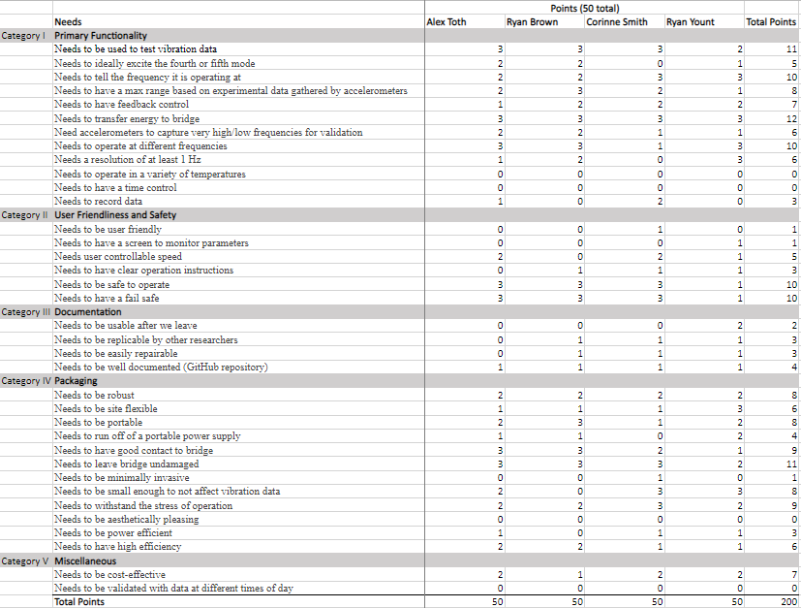

Table 2. Second round of needs ranking.

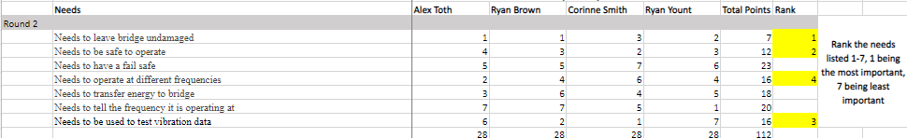

Format:

• 12pt font, 1” margins all around

• Text in paragraph form MUST BE DOUBLE-SPACED

• Numbered or bulleted lists, and Tables should all be SINGLE SPACED

• Page numbering must be in the footer of all pages

• Your Team name (i.e. project sponsor) must be in the Header at the top of all pages

• Label/Title each subsection with similar wording and numbering schema as above

• All tables must be numbered and titled as supplied in the Guidelines Document in BB

• Total amount of BODY TEXT (excluding tables) must be 3 (double-spaced) pages OR LESS!